Types of Nominal Predicates
# Source: AI Source: Provided by: [Data Path: Persons Table -> ID Column: 1, Name_En Column: Motasem Essam] -> From: [ChatGPT] on [8/4/2025]
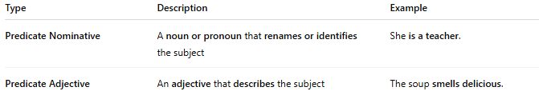

Type | Description | Example
Predicate Nominative | A noun or pronoun that renames or identifies the subject | She is a teacher.
Predicate Adjective | An adjective that describes the subject | The soup smells delicious.

